CREATE DATABASE HR_Analytics;
USE HR_Analytics;
SELECT * from hr_analytics;
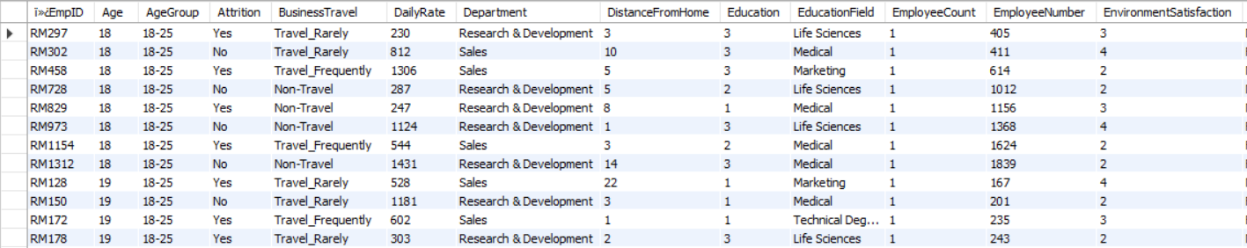
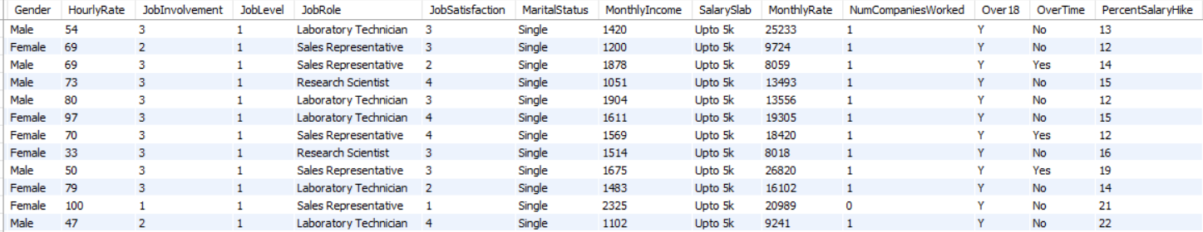
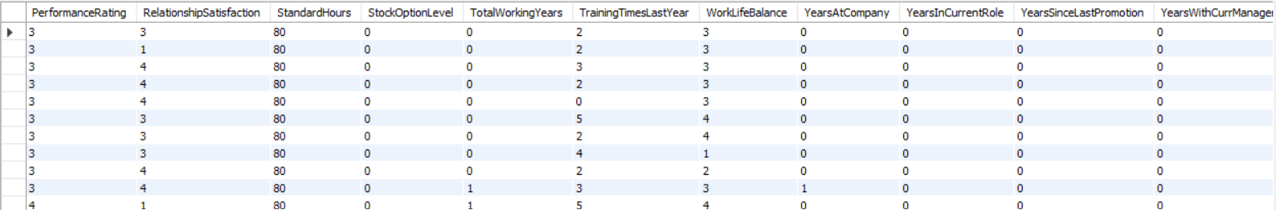
#1. How many total employees are in the dataset?
SELECT COUNT(EmployeeCount) FROM hr_analytics;
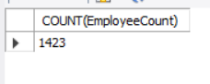
#2. How many columns/features are present?
SELECT COUNT(*)
FROM information_schema.columns
WHERE table_name = 'hr_analytics';
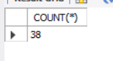
#3. What are the distinct job roles available?
SELECT DISTINCT JobRole FROM hr_analytics;
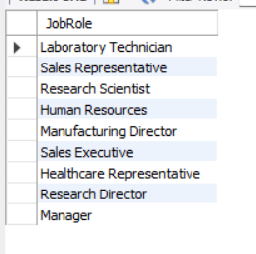
#4. How many employees are there in each department?
SELECT Department, COUNT(*) AS total_employees
FROM hr_analytics
GROUP BY Department;
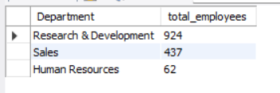
#5. What is the gender distribution of employees?
SELECT Gender, COUNT(*) AS total_employees
FROM hr_analytics
GROUP BY Gender;
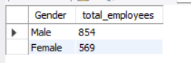
#6. What is the distribution of marital status?
SELECT MaritalStatus, COUNT(*) AS distribution_MaritalStatus
FROM hr_analytics
GROUP BY MaritalStatus;
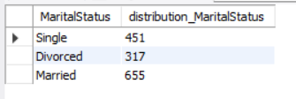
#7. What is the overall attrition count?
SELECT Attrition, COUNT(*) AS total_attrition
FROM hr_analytics
GROUP BY Attrition;
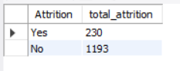
#8. What is the average age of employees?
SELECT AVG(Age) AS AVG_AGE
FROM hr_analytics;
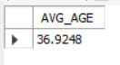
#9. What are the minimum and maximum salaries?
SELECT MIN(MonthlyIncome) AS MIN_SALARY, MAX(MonthlyIncome) AS MAX_SALARY
FROM hr_analytics;
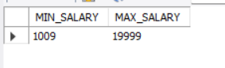
#10. How many employees belong to each education field?
SELECT EducationField, COUNT(*) AS total_employees
FROM hr_analytics
GROUP BY EducationField;
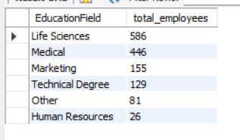
#11. What is the overall attrition rate?
SELECT AVG(Attrition) AS attrition_rate FROM hr_analytics;
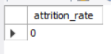
#12. Which department has the highest attrition?
SELECT Department, Attrition FROM hr_analytics
ORDER BY Department DESC;
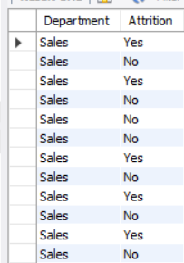
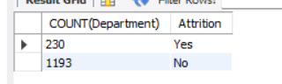
#13. Which gender has higher attrition?
SELECT Age, Attrition FROM hr_analytics
ORDER BY Age DESC;
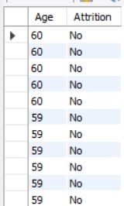
#14. Which job role has the highest attrition?
SELECT JobRole, Attrition FROM hr_analytics
ORDER BY JobRole DESC;
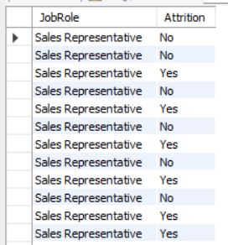
#15. Does overtime impact attrition?
SELECT OverTime, count(*) AS total_overtime FROM hr_analytics
GROUP BY OverTime;
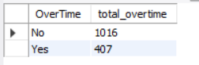
#16. Which age group has the highest attrition?
SELECT AgeGroup, COUNT(attrition) FROM hr_analytics
GROUP BY AgeGroup
ORDER BY AgeGroup DESC;
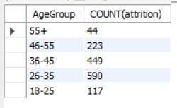
#17. How does salary range affect attrition?
SELECT
CASE
WHEN MonthlyIncome < 3000 THEN 'Low Salary'
WHEN MonthlyIncome BETWEEN 3000 AND 6000 THEN 'Medium Salary'
ELSE 'High Salary'
END AS salary_range,
COUNT(*) AS total_employees,
SUM(CASE WHEN Attrition = 'Yes' THEN 1 ELSE 0 END) AS attrition_count,
ROUND(
SUM(CASE WHEN Attrition = 'Yes' THEN 1 ELSE 0 END) * 100.0 / COUNT(*),
2
) AS attrition_rate
FROM hr_analytics
GROUP BY salary_range
ORDER BY attrition_rate DESC;
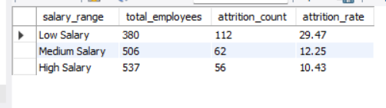
#18. Which education field has the highest attrition?
SELECT EducationField, COUNT(Attrition) FROM hr_analytics
GROUP BY EducationField
ORDER BY EducationField DESC;
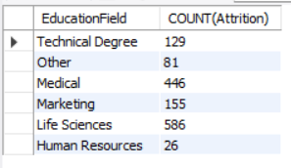
#19. Does business travel affect attrition?
SELECT BusinessTravel, COUNT(*)
FROM hr_analytics
GROUP BY BusinessTravel;
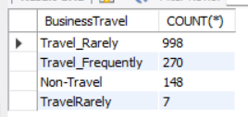
#20. How does job level impact attrition?
SELECT JobLevel, COUNT(*) FROM hr_analytics
GROUP BY JobLevel;
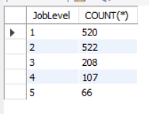
#21. What is the average salary by department?
SELECT Department, AVG(MonthlyIncome) AS avg_salary
FROM hr_analytics
GROUP BY Department;
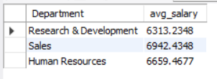
#22. What is the average salary by job role?
SELECT JobRole, AVG(MonthlyIncome) AS AVG_SALARY
FROM hr_analytics
GROUP BY JobRole;
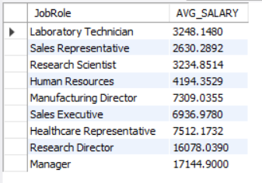
#23. Who are the highest paid employees?
SELECT JobRole, MonthlyIncome FROM hr_analytics
ORDER BY JobRole DESC;
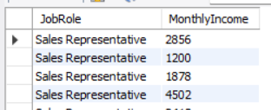
#24. Is there a salary difference between employees who left and stayed?
SELECT Attrition, AVG(MonthlyIncome) AS AVG_SALARY
FROM hr_analytics
GROUP BY Attrition;
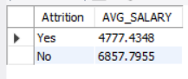
#25. Is there a gender-based salary gap?
SELECT Gender, MonthlyIncome
FROM hr_analytics
WHERE MonthlyIncome;
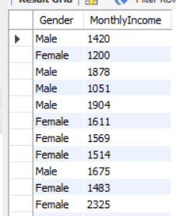
#26. How does salary hike differ between employees who left and stayed?
SELECT Attrition, ROUND(AVG(PercentSalaryHike),2)
AS AVG_SALARY_HIKE
FROM hr_analytics
GROUP BY Attrition;
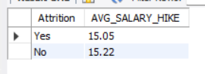
#27. Do stock options reduce attrition?
SELECT count(StockOptionLevel) AS Total_stock, Attrition FROM hr_analytics
GROUP BY Attrition;
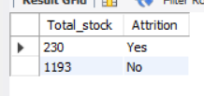
#28. What is the distribution of employees across salary ranges?
SELECT count(*) AS EMPLOYEE_COUNT, MonthlyIncome AS RANGE_SALARY
FROM hr_analytics
GROUP BY MonthlyIncome;
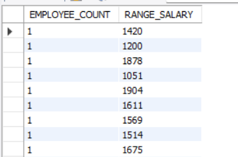
#29. Which job roles offer the highest average salary?
SELECT JobRole, AVG(MonthlyIncome) AS AVG_SALARY
FROM hr_analytics
GROUP BY JobRole
ORDER BY JobRole DESC;
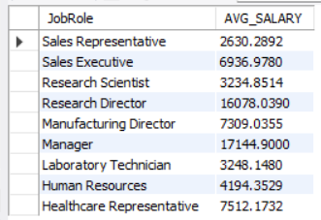
#30. Which department pays the highest average salary?
SELECT Department, AVG(MonthlyIncome) AS AVG_SALARY
FROM hr_analytics
GROUP BY Department
ORDER BY Department DESC;
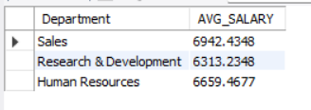
#31. What is the average total working experience of employees?
SELECT count(*) AS total_working_experience, avg(TotalWorkingYears)
FROM hr_analytics
GROUP BY TotalWorkingYears;
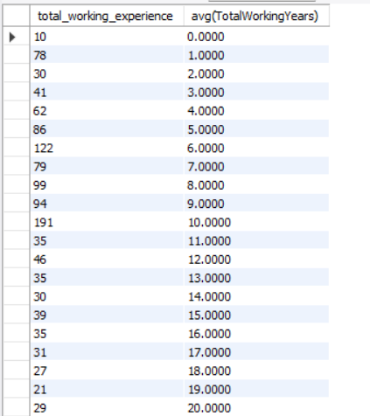
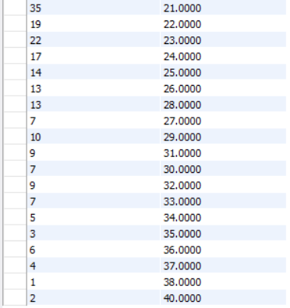

#32. What is the average tenure at the company?
SELECT AVG(YearsAtCompany) AS AVG_TENURE
FROM hr_analytics;
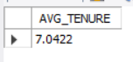
#33. Does attrition increase with fewer years at the company?
SELECT YearsAtCompany, COUNT(Attrition) AS ATTRITION_COUNT
FROM hr_analytics
GROUP BY YearsAtCompany
ORDER BY YearsAtCompany ASC;
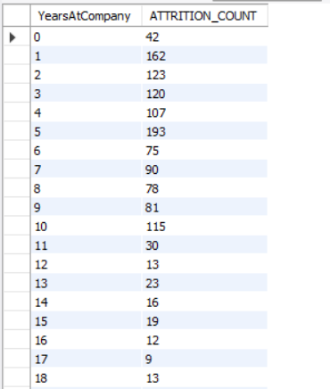
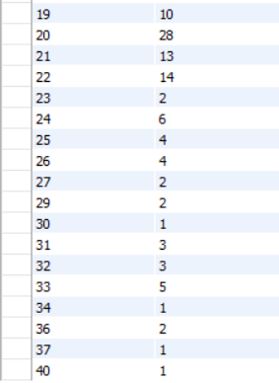

#34. What is the average time since last promotion?
SELECT AVG(YearsSinceLastPromotion) AS AVG_TIME_SINCE_LAST_PROMOTION
FROM hr_analytics;
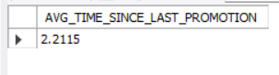
#35. How does experience affect salary?
SELECT TotalWorkingYears, MonthlyIncome
FROM hr_analytics
ORDER BY TotalWorkingYears DESC;
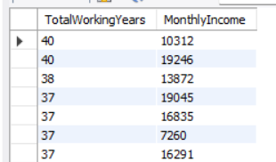
#36. How many employees have never been promoted?
SELECT COUNT(*) AS EMPLOYEES_NEVER_PROMOTED
FROM hr_analytics
WHERE YearsSinceLastPromotion = 0;
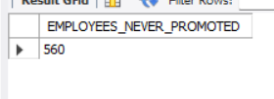
#37. Who has the longest tenure in the company..?
SELECT YearsAtCompany AS longest_TENURE
FROM hr_analytics
ORDER BY YearsAtCompany DESC;
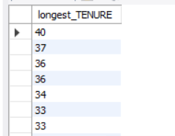
#38. Does manager tenure attrition?
SELECT YearsWithCurrManager, COUNT(*) AS count_attrition
FROM hr_analytics
GROUP BY YearsWithCurrManager
ORDER BY YearsWithCurrManager;
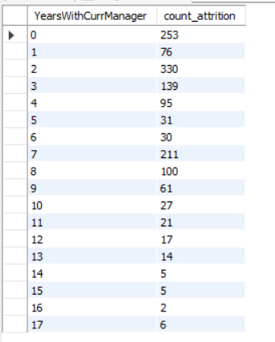
#39. How long do employees stay with the same manager?
SELECT AVG(YearsWithCurrManager) AS AVG_YEARS_WITH_MANAGER
FROM hr_analytics;
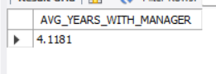
#40. How often do employees switch companies?
SELECT AVG(NumCompaniesWorked) AS AVG_COMPANY_SWITCHED
FROM hr_analytics;
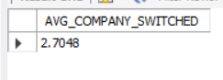
#41. What is the average job satisfaction level?
SELECT AVG(JobSatisfaction) AS AVG_JOB_SATISFACTION_LEVEL
FROM hr_analytics;
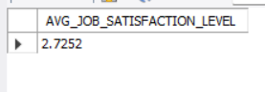
#42. Does low job satisfaction lead to higher attrition?
SELECT MIN(JobSatisfaction) AS low_job_satisfaction,
MAX(Attrition) AS higher_attrition
FROM hr_analytics;
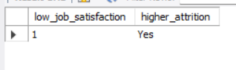
#43. How does work-life balance affect attrition?
SELECT WorkLifeBalance, COUNT(Attrition) AS count_attrition
FROM hr_analytics
GROUP BY WorkLifeBalance;
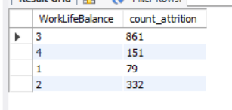
#44. What is the distribution of environment satisfaction?
SELECT EnvironmentSatisfaction, COUNT(*)
FROM hr_analytics
GROUP BY EnvironmentSatisfaction
ORDER BY EnvironmentSatisfaction;
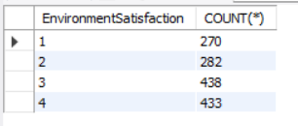
#45. What is the distribution of performance ratings?
SELECT PerformanceRating, COUNT(*)
FROM hr_analytics
GROUP BY PerformanceRating
ORDER BY PerformanceRating;
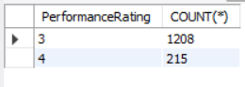
#46. Does higher performance lead to higher salary?
SELECT PerformanceRating, MonthlyIncome
FROM hr_analytics
ORDER BY PerformanceRating DESC;
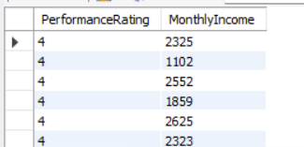
#47. How many employees have low job satisfaction?
SELECT COUNT(*) AS EMP_LOW_JOB_SATISFACTION, JobSatisfaction
FROM hr_analytics
GROUP BY JobSatisfaction;
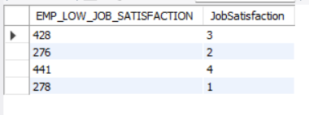
#48. How many employees with low satisfaction left the company?
SELECT EnvironmentSatisfaction, COUNT(*) AS employees_with_low_satisfaction
FROM hr_analytics
WHERE Attrition = 'Yes'
GROUP BY EnvironmentSatisfaction
ORDER BY EnvironmentSatisfaction;
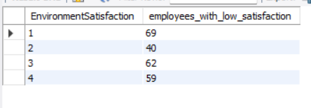
#49. Deos overtime impact job satisfaction?
SELECT COUNT(JobSatisfaction), OverTime
FROM hr_analytics
GROUP BY OverTime;
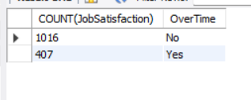
#50. How do job satisfaction and work-life balance together affect attrition?
SELECT JobSatisfaction, WorkLifeBalance, COUNT(*) AS ATTRITION_COUNT
FROM hr_analytics
WHERE Attrition = 'YES'
GROUP BY JobSatisfaction, WorkLifeBalance
ORDER BY JobSatisfaction, WorkLifeBalance;
